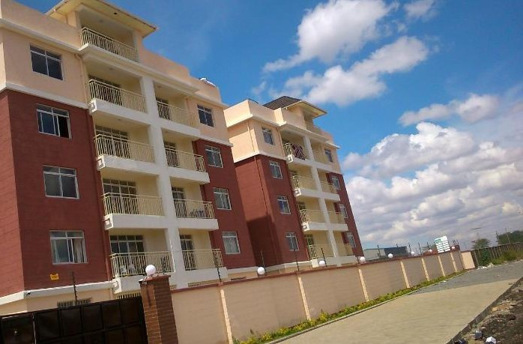


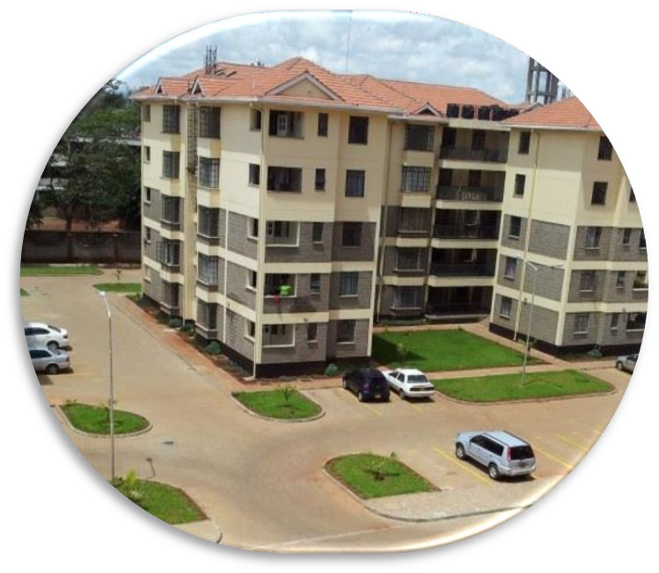
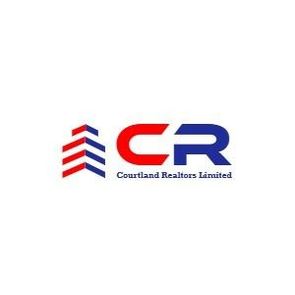

Registered Real Estate Agents



PROPERTY MANAGEMENT PROFILE
ADDRESS: P.O BOX 11993-00100, NAIROBI – KENYA
OFFICE LOCATION: RUAKA SUITE C3 2ND FLOOR UPENDO HOUSE
(KARIUKI DRIVE)




To offer professional, reliable, and personalized real estate services; rooted in integrity and innovation, while creating long-term value for clients in Ruaka, Kenya, and beyond.

To be the most trusted and innovative real estate company in Ruaka, with a growing impact across Kenya, Africa, and the world, delivering excellence in every property solution we provide.

OUR CORE VALUES
At Courtland Realtors, our values guide every interaction, every deal, and every step we take.

1. QUALITY
We are committed to delivering only the highest standards in everything we do, striving to exceed expectations and add real value.

2. INTEGRITY
We act with honesty, fairness, and transparency in every decision and action, earning the trust of our clients and partners.

3. ABILITY
We are solutions-driven professionals who respond quickly and competently to every client need.

4. COURAGE
We make bold, ethical decisions in the best interests of our clients,
even in challenging situations.

5. RESPECT & TRUST
We treat all people; clients, partners, and team members, with dignity and professionalism, building strong, respectful relationships.

6. INNOVATION
We embrace modern tools, technology, and fresh ideas to provide smarter, faster, and more effective real estate solutions.

7. SUSTAINABILITY
We promote responsible property practices and support developments that positively impact
the community and environment.

8. TEAM SPIRIT & FUN
We value collaboration, celebrate wins, and create an enjoyable and supportive work
environment.

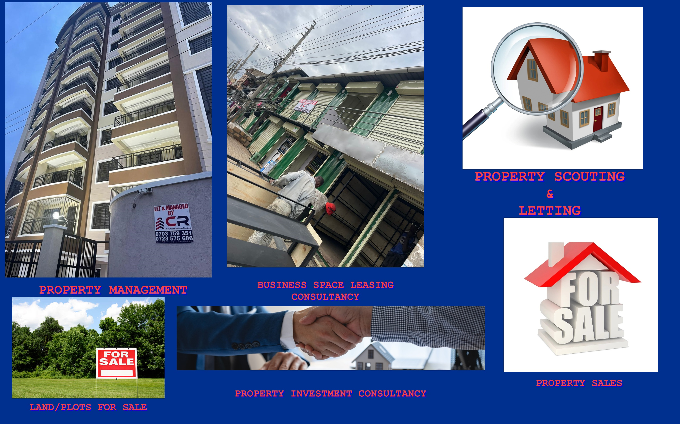
PROPERTY SALES AND LETTING.

At Courtland Realtors Ltd, we specialize in the sale and letting of both residential and commercial properties across Ruaka and Kenya at large.
Our in-depth local market knowledge, combined with modern marketing tools, ensures properties are positioned to attract the right buyers or tenants, quickly and at the best value.
We offer:
- A wide database of verified listings
- Professional photography and virtual tours
- E-marketing and social media promotion
- Brochures, signage, and open-house events
- Targeted outreach to our network of investors and clients
Our experienced team handles the entire process: from property valuation, marketing, and client screening to legal documentation, negotiation, and closing. We also advise owners on pricing strategy and improvements that increase property value and reduce vacancy periods.
By working with us, you gain access to high-quality leads, faster turnaround times, and a dedicated team that prioritizes
your property goals.
We don’t just sell or let property, we help you unlock its full potential.

PROPERTY / ASSET MANAGEMENT
Courtland Realtors Ltd offers comprehensive property and asset management services tailored to meet the needs of individual landlords, property owners, and investors.
We manage both residential and commercial properties, ensuring smooth day-to-day operations, timely rent collection, reliable tenant relations, and consistent property maintenance.

🔹 Our Services Include:
- Monthly rent collection & arrears follow-up
- Timely deposits to landlord accounts
- Handling tenant requests, complaints & lease renewals
- Payment of utility bills, service charge, and statutory fees
- Coordinating repairs, maintenance, and service providers
- Supervising caretakers, cleaners & security staff
- Generating monthly reports & financial statements
- Property inspections & move-in/move-out coordination
We charge a 5% monthly commission on rent collected, with flexible arrangements depending on the scope of services required.
Our goal is to maximize property value, retain quality tenants, and offer landlords peace of mind through reliable and
transparent management.
With Courtland Realtors, your property is in capable,
committed hands.

🔹 MANAGEMENT SERVICES
We oversee the full tenancy lifecycle and day-to-day operations, including:
- Drafting and executing tenancy agreements
- Move-in and move-out inspections
- Lease renewals and negotiations
- Tenant screening, background and credit checks
- Routine property inspections
- Tenant communication and issue resolution
- Preparation of monthly management and financial reports

🔹 MAINTENANCE & REPAIR
We work closely with landlords and service providers to ensure properties remain in excellent condition:
- Scheduling and coordinating regular maintenance and repairs
- Preparing vacant units for new tenants
- Supervising cleaning, landscaping, and common-area upkeep
- Managing emergency repair response
- Implementing preventive maintenance plans
- Advising landlords and developers on current market finishes and standards
We manage every detail so you don’t have to, ensuring smooth operations, satisfied
tenants, and protected investments.

🔹 FINANCIAL REPORTING & PAYMENTS
We maintain accurate and timely financial management on behalf of property owners, including:
- Prompt rent collection and deposit to landlord accounts (less agreed commission)
- Service charge invoicing and collection
- Tracking of management, letting, and administrative fees
- Disbursement of payments to vendors, contractors, and service providers
- Processing of statutory payments such as property taxes, insurance, and debt servicing (if requested)
We provide clear and detailed financial reports to property owners to support informed decision-making.

🔹 CLEANING & SECURITY OVERSIGHT
We ensure properties remain clean, safe, and well-maintained by:
- Supervising caretakers and cleaning staff
- Coordinating regular garbage collection with approved providers
- Monitoring the quality of cleaning and grounds upkeep
- Advising on and supporting security arrangements where applicable
Through proper financial controls and consistent property care, we help protect and grow the value of your investment.

EXAMPLES OF MANAGEMENT DEPARTMENT OPERATIONS

LETTING PROCEDURE
Our letting process is designed to be transparent, structured, and tenant-friendly, while safeguarding the interests of property owners. Below is a step-by-step breakdown of how we manage new tenant on-boarding:

🔹 Step-by-Step Letting Process
- Property Viewing
The prospective tenant is accompanied to view the available unit and assess its suitability.
- Filling the Memorandum of Letting
Interested tenants complete a memorandum form with their personal details and intent to lease.
- Lease Agreement Preparation
In collaboration with our legal partners, we draft a customized lease agreement in accordance with local regulations.
- Signing the Lease Agreement
The tenant is guided through the lease terms before signing(never done under duress). Required documents include a copy of their ID/passport, the memorandum of letting, and employment details.
- Inventory & Inspection
A joint inspection is conducted with the tenant to document the unit's condition, including fixtures and fittings.
- Payment of Rent & Deposits
The tenant pays the agreed rent and security deposit as outlined in the lease agreement.
- Key Handover & Occupation
Once all steps are completed, the tenant receives the keys and is granted full access to the property.
Our streamlined letting process ensures both tenant satisfaction and landlord
peace of mind.

RENT & SERVICE CHARGE COLLECTION PROCEDURE
At Courtland Realtors Ltd, we implement a structured and transparent rent collection process that ensures timely payments and accountability, while maintaining professional communication with tenants.

🔹 Payment Guidelines
- Tenants are required to deposit rent directly into the designated bank accounts and settle utility bills with service providers.
- Copies of deposit slips or payment receipts must be forwarded to our office for verification and record keeping.
- Rent is due by the 5th of every month.

🔹 Follow-Up Procedure for Late Payments
If rent is not received by the due date, the following steps are taken:
- First Reminder – A 7-day notice is issued to the tenant requesting settlement of rent arrears.
- Final Notice – If payment is still pending, a 3-day final notice is served.
- Legal Notice – A 24-hour legal notice is issued, referencing previous notices and the tenant's payment statement.
- Auctioneer Engagement – If the tenant fails to respond, licensed auctioneers are notified and a 14-day auction notice is issued.
- Break-in Order – Where necessary, the auctioneers may obtain a break-in order to access the premises legally.
This system ensures timely rent recovery while upholding due legal
process and clear communication.

REPAIRS, INSPECTIONS & MANAGEMENT DOCUMENTS

🔹 Repair & Maintenance Procedure
We follow a structured workflow to ensure all repair and maintenance issues are addressed promptly and professionally:
- Reporting – Tenants or caretakers report maintenance issues to our management team.
- Documentation – Each request is logged using an official Repairs & Maintenance Form.
- Approval – The request must be approved by the Property Manager, CEO, and the Property Owner.
- Execution – Once approved, materials are sourced and the repair is carried out by authorized personnel.

🔹 Unit Inspection Procedure
We conduct thorough inspections during both tenant move-in and move-out. These inspections are carried out jointly by a trained representative from our office and a qualified technical expert, ensuring accuracy and accountability.

🔹 Key Management Documents
House Letting Documents
- Tenancy Agreement
- Memorandum of Letting
- Inspection Inventory Form
- Tenant Bio-Data Template
Management Contracting Documents
- Property Details Form
- Service Agreement
- Management Proposal
- Copy of National ID/Passport
Tenancy Clearance Documents
- Tenancy Termination Letter (one-month written notice)
- Final Inventory Inspection Form
- Clearance Form
Rent Collection Documents
- Polite Reminder
- Final Reminder
- Legal Notice
- Tenancy Termination Letter
Rent Deposit Refund Documents
- Rent Payment/Clearance Statement
- Utility Bills Clearance statement
- Exit Repairs Clearance Statement
- Copy of ID and Deposit Refund Receipt

Our documentation framework ensures that all property processes are legally compliant, well-documented, and smoothly executed.

COMPANY EXPERIENCE
PROPERTY | TASKS | CLIENT
LYNN APARTMENTS  (RUAKA) | Letting services, where we increased occupancy from 70% - 100% | MERCY GACHOYA
RUNDA GARDENS | Letting services | AZIZI
RUAKA VALLEY APARTMENT | Letting services | CREEK VIEW LTD
RUAKA SQUARE  (COMMERCIAL) | General Property letting, landlord advisory services. | COUNTY HOMES DEVELOPERS
RUAKA ARCADE | General property management, supervision of cleaning, collection of service charge, security, monitoring vacating of rooms. | CLAMMED SHELTERS
DAINTY APARTMENT | Letting and sale of vacant units | DAINTY HOLDINGS
PEARL COURT | Sales & Letting | PEARLCOURT DEVELOPERS
EDENVILLE | Selling & Letting | MONICA
MONICA APARTMENT | Full management | MONICA
PRIANNA SUITES | Full management services (letting of vacant units, garbage collection, etc) | ARNEST NJIRU
QYOTA APARTMENTS | Full management services (letting of vacant units, garbage collection, etc) | JANE WANJIRU
SHANAYA SUITES | Full management services (letting of vacant units, garbage collection, etc) | MUNYUI
SUNFLOWER APARTMENT | Full management services (letting of vacant units, garbage collection, etc) | MARGARET MBUGUA
NJENY HEIGHTS | Full management services (letting of vacant units, garbage collection, etc) | NJEKIRU
BORDER BUSINESS CENTER | Full management services (letting of vacant units, garbage collection, etc) | JANE
ANA APARTMENT | Full management services (letting of vacant units, garbage collection, etc) | ANN

LETTING/MANAGEMENT COMMISSION AND PROPERTY RENT ESTIMATES
Letting Estimates (Ruaka Town) Executive Apartments

NO OF BEDROOMS | DETAILS | RENT RANGE  (per month)
1 Bedroom | Self-contained with a closed kitchen & parking  Self-contained with an open plan kitchen & parking | Kes 20,000 – 25,000  Kes 15,000 – 20,000
2 Bedrooms | Master en-suite with parking  Non en-suite/double cloak rooms & parking | Kes 35,000 – 40,000  Kes 30,000 – 35,000
3 Bedrooms | All en-suite & parking  Only master en-suite & parking  Open plan kitchen/master en-suite & parking | Kes 45,000 – 50,000  Kes 40,000 – 45,000  Kes 45,000 – 50,000

Management/Letting commission estimates

NO | ITEM | COMMISSION ESTIMATES
1 | LETTING COMMISSION | We charge a 10/20/50/100 % of the first month’s rent only
2 | MANAGEMENT COMMISSION | We charge between 5 to 10% of the total rent collected per month.

Management/Letting commission estimates

NO | ITEM | COMMISSION ESTIMATES
1 | LETTING COMMISSION | We charge a 10/20/50/100 % of the first month’s rent only
2 | MANAGEMENT COMMISSION | We charge between 5 to 10% of the total rent collected per month.

N/B: We do not charge additional charges for regular evictions; however additional legal fees, court charges and expenses will apply provided the landlord (lady) is notified before. Our commissions are also negotiable

SOME OF OUR CLIENTELE/PROPERTIES INCLUDE

- Kencom Sacco – Azizi
- Capital Heights – Ruaka
- Ruaka valley apartments – Ruaka
- Runda view apartments – Ruaka
- Ruaka Arcade – Ruaka
- Creek View Developers – Parklands
- Two Rivers Mall – Ruaka
- Ruaka Square – Ruaka
- Dainty Apartment – Thindigwa
- Ruaka Landmark Plaza – Ruaka
- Pearl court Apartments – Ruaka
- Morning star apartments –Ruaka
- Centric Court Apartments – Kiambu Road
- Lynn Apartments – Ruaka
- Njeny Heights – Ruaka
- Border Business Center – Ruaka
- Ana Apartment – Ngong’

Let’s Work Together

At Courtland Realtors Ltd, we are committed to delivering services rooted in integrity, professionalism, and excellence. Our promise is to provide dependable, transparent, and client-focused real estate solutions, whether you're a landlord, investor, or tenant.
We welcome the opportunity to partner with you and add value to your property investment.
For more information about our property management and real estate services, feel free to schedule a one-on-one consultation with our team, Director, or any of our marketing representatives.

We would be honored to have you as our business partner.



